Optimization Of Supply Chain Management Using Genetic Algorithm

Cezmi Mert Ünaldı

Mathematical Engineering – Faculty of Science and Letters

090210734

Adv.Scientific & Eng.Computing

December 23th, 2022

Content

Defining of Problem ………………………..…………………………………...…………… 3

Formulation ………………………….……………………………………………….……… 3

MATLAB Codes ……….…………..……………………...………………………………… 4

Result ………………………………………………………………………………………… 4

Defining of Problem

Supply Chain Management is the management that ensures that the right product is delivered to the customer at the right time, at the right place, at the right price, that is, at the lowest cost by integrating all processes. I will code the optimization program of the supply chain management with the genetic algorithm to optimize the cost without using the time parameter.

Formulation



The equation we need to minimize is:

Cost = $\sum_{i,j}{a*x \sum_{k,j}{b*y}}$

R → Customer request

D → Capasity of Distributor

P → Capasity of Manufacturer

Constraints of the equation:

$\sum_{j}{x_{ji}≥R_{i}}$ ∀i

$\sum_{i}{x_{ji}≤D_{j}}$ ∀j

$\sum_{i}{x_{ji}=\sum_{k}{y_{kj}}}$ ∀j

$\sum_{j}{y_{kj} ≤P_{k}}$ ∀k

$y_{kj},x_{ji}≥0$

MATLAB Codes

1. I wrote the function named model=createmodel(). It has no input value. I wrote this function to generate the number of customers, the number of distributors, the number of factories, their capacities and price data.

x1+x2+x3+……+xn=C

0≤ x̄n≤1 $x_{n }=(C* {\bar{x}}_{n})/(x_{1}+x_{2}+x_{3}+…+x_{n})$

I wrote the sol1=randomsolution(model) function that randomly generates the "xhat" and “yhat” values required to find values of x.

1. I wrote a function called sol2=parsesolution(sol1,model)that calculates the real x and y values, the error that may occur, the cost of the error, and then the total cost, using the generated "xhat" and "yhat" random values.
2. I wrote a cost function named “mycost” using the Parsesolution function to use in the main code directory.
3. Crossover is one of the foundations of genetic algorithm. I randomly selected and modified the data to be replaced using the uniform crossover method. I later named this function "uniformcrossover".

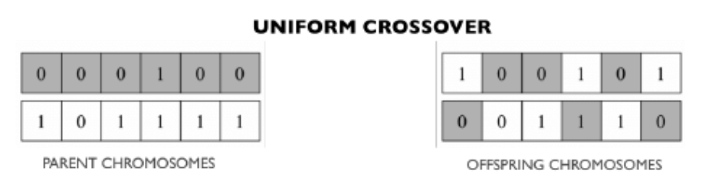

1. Another important function in genetic algorithm is mutation function. I wrote a function called "mutate" that mutates 50 percent of the gene selected by tournament selection.
2. I wrote a function called "tournamentselection" which is used to choose both random and the best ones. This function was used with the "mutate" and "crossover" functions.
3. I created individuals with cost, position and solution using struct in main code directory. I would also combine all individuals under the population struct. Then, using the functions I created, I performed genetic operations on the positions of the individuals. I plotted the best result found in each iteration. Finally i found the minimum cost.

Result

Solving an optimization problem using a genetic algorithm is a quick way to get results. Solving an optimization problem using a genetic algorithm is a quick way to get results. I learned a lot about genetic algorithm with this project. I learned the "struct" in the MATLAB program, which we did not learn in the lesson, and it helped me a lot in solving this problem. To solve this problem, I created 7 functions and 1 main code directory.